**Visvesvaraya Technological University**

Belagavi



**A Mini Project Report**

**on**

**IOT Based Smart Plant Monitoring System**

***Submitted by***

**MOHAMMED SHARUK M S USN:1NH21EC408**

**PTM.S. MOHAMMED FAIZAN USN:1NH20EC107**

***In partial fulfilment for the award of the***

***degree of***

**BACHELOR OF ENGINEERING**

**IN**

**ELECTRONICS AND COMMUNICATION ENGINEERING**





**Bengaluru – 560 103**

**DEPARTMENT OF ELECTRONICS AND COMMUNICATION ENGINEERING**

**CERTIFICATE**

Certified that the Mini project entitled “IOT Based Smart Plant Monitoring System” is carried out by NAME------------- bearing USN---------and NAME bearing USN, Bonafide students of NHCE, Bengaluru in partial fulfilment for the award of Bachelor of Engineering in Electronics and Communication of the Visvesvaraya Technological University, Belagavi during the year 2022-23. It is certified that all corrections and suggestions indicated for Internal Assessment have been incorporated in the report deposited in the department library. The mini project report has been approved as it satisfies the academic requirements in respect of the mini project work prescribed for the said degree.

|  |  |
| --- | --- |
|  |  |
| Signature of the guide  ------------  Senior Assistant Professor  Department of ECE  NHCE,Bengaluru | Signature of the HoD  Dr. Aravinda K  Professor & HoD  Department of ECE  NHCE,Bengaluru |

|  |  |
| --- | --- |
| Name of the Examiner | Signature of the Examiner |
| 1. | 1. |
| 2. | 2. |

**ACKNOWLEDGEMENT**

The satisfaction and euphoria that accompany the successful completion of any task would be impossible without the mention of the people who made it possible, whose constant guidance and encouragement crowned our efforts with success.

We have great pleasure in expressing gratitude to **Dr. Mohan Manghnani**, Chairman, New Horizon Educational Institutions, for providing necessary infrastructure and creating good environment.

We take this opportunity to express our profound gratitude to **Dr. Manjunatha,** Principal, New Horizon College of Engineering, for his constant support and encouragement.

We would also like to thank **Dr. Aravinda K** Professor and HOD, Department of Electronics and Communication Engineering, for his constant support.

We also express our gratitude to **-------------** Senior Assistant Professor, our project guide, for constantly monitoring the development of the project and setting up precise deadlines. Their valuable suggestions were the motivating factors in completing the work.

Finally, a note of thanks to all the teaching and non-teaching staff of Dept of Electronics and communication Engineering, for their cooperation extended to us, and our parents and friends, who helped us directly or indirectly in the course of the project work.

Submitted by

MOHAMMED SHARUK M S

PTM.S. MOHAMMD FAIZAN

**ABSTRACT**

As we can see, only a select few gadgets, such as PCs and smartphones, are internet-connected in the modern world. Internet of Things (IoT) and the internet have completely taken over today's world. All humans utilise the internet to fulfil basic needs. The network of actual items is known as the Internet of Things (IOT). Simply put, it refers to the process of keeping an eye on a physical machine or object. It can also refer to the interconnection of physical objects that have been implanted with electronics, sensors, software, and network connectivity.

Through network infrastructure, IOT enables remote sensing or control of items. As a result, accuracy, financial gains, and efficiency increase while human intervention decreases.

We will discuss the fundamental ideas of IOT as well as its potential in the future in this essay. This essay examines the use of IOT in daily life for various applications and provides a quick primer on the technology. IOT makes a substantial contribution to cutting-edge farming techniques. Therefore, we are attempting to show IOT with an automatic watering system. The approximate moisture level of the soil is monitored and maintained using an automatic watering system. The control unit is implemented using an Arduino UNO as a microcontroller. The system makes use of sensors to measure the approximate temperature, moisture content, and humidity of the soil: temperature, moisture, and humidity. This value enables the system to use the proper amount of water, preventing excessive or insufficient irrigation.

**CONTENTS**

|  |  |  |  |  |
| --- | --- | --- | --- | --- |
| **Chapter** | |  | **Title** | **Page No** |
|  |  |  |  |  |
|  |  |  | List of Figures | vii |
|  |  |  |  |  |
| 1 |  |  | Introduction | 8 |
|  |  |  |  |  |
| 2 |  |  | Literature Review | **9** |
|  |  |  |  |  |
| 3 |  | Fig1.0Fig1.1  Fig1.2  Fig1.3 | Existing System | 10-11 |
|  |  |  |  |  |
| 4 |  | Fig1.4 | Proposed System | 12-13 |
|  |  |  |  |  |
| 5 |  | Fig1.5  Fig1.6  Fig1.7  Fig1.8  Fig1.9 | Hardware and Software Specifications | 14-20 |
|  |  |  |  |  |
| 6 |  | Fig2.0  Fig2.1 | Block Diagram | 21 |
|  |  |  |  |  |
| 7 |  |  | Advantages and Applications & Limitations | 22-23 |
|  |  |  |  |  |
| 8 |  |  | Results and Discussion | 24 |
|  |  |  |  |  |
| 9 |  |  | Future scope and Conclusion | 25 |
|  |  |  |  |  |
|  |  |  | Appendix |  |
|  |  |  | References |  |
|  |  |  |  |  |

**LIST OF FIGURES**

Figure Title Page No

1.0-1 Arable 09

1.2 Edyn 10

1.3-4 Parrot Pot 10

1.5 Developed app 13

1.6 Wi-Fi Module 14

1.7 Soil moisture sensor 15

1.8 Temperature sensor 15

1.9 Relay module 16

2.0 Solenoid water valve 16

2.1 Block Diagram 21

2.2 Circuit Diagram 21

**CHAPTER 1**

**INTRODUCTION**

An Internet of Things (IoT)-based plant monitoring system is a system that uses sensors and other monitoring devices to collect data on various aspects of plant health and growth. This data is then transmitted to a central hub or cloud platform, where it can be analyzed and used to optimize the care of plants.

One common use of an IoT-based plant monitoring system is in agriculture. This is because it can be used to optimize irrigation and fertilization, track pest and disease outbreaks, and monitor the overall health of crops. It can also be used in greenhouses, gardens, and other plant-growing environments to optimize growing conditions and ensure that plants receive proper care.

An IoT-based plant monitoring system typically includes sensors that measure various parameters such as soil moisture, temperature, humidity, light intensity, and nutrient levels. The sensors are connected to a central hub or gateway, which transmits the data to the cloud for analysis and storage. The system may also include actuators, such as automated irrigation systems or ventilation systems, that can be controlled based on the data collected by the sensors.

Overall, an IoT-based plant monitoring system can help improve the efficiency and productivity of plant-growing operations, while also reducing the time and effort required to care for plants.

Sensors: The sensors used in an IoT based plant monitoring system can measure a wide range of parameters, depending on the needs of the plants being grown. For example, soil moisture sensors can help farmers optimize irrigation schedules, while temperature and humidity sensors can help greenhouses maintain the proper growing conditions for plants. Other sensors measure light intensity, nutrient levels, pH, and other parameters that are relevant for plant growth.

Data analysis: The data collected by the sensors is typically transmitted to a central hub or cloud platform, where it can be analyzed and used to optimize plant care. For example, if soil moisture levels are too low, the system may trigger an irrigation event to ensure that the plants receive enough water. Alternatively, if nutrient levels are too high, the system may recommend adjusting the fertilization schedule or taking other corrective actions.

Remote monitoring: One of the key benefits of an IoT-based plant monitoring system is the ability to remotely monitor and control plants from anywhere with an internet connection. This can be especially useful for large-scale agricultural operations, where it may not be practical for a farmer to physically check each field or greenhouse. By accessing the data collected by the sensors via a smartphone or computer, farmers can stay informed about the health and growth of their plants in real-time and make any necessary adjustments as needed. Sensors: The sensors used in an IoT-based plant monitoring system can measure a wide range.

**CHAPTER 2**

**LITERATURE REVIEW**

**IoT-based plant monitoring systems in agriculture**

A study published in the journal Sensors (Basu et al., 2018) examined the use of IoT-based plant monitoring systems in agriculture, focusing on the benefits and challenges of implementing such systems. The authors found that IoT-based plant monitoring systems can help optimize irrigation and fertilization schedules, reduce the use of pesticides and herbicides, and improve crop yields. However, they also noted that there are challenges to implementing these systems, including the cost of installing and maintaining sensors and other hardware, as well as the need for reliable internet connectivity.

**IoT-based plant monitoring systems in greenhouses**

Another study published in the journal Computers and Electronics in Agriculture (Dalessandro et al., 2019) looked at the use of IoT-based plant monitoring systems in greenhouses. The authors found that these systems can help optimize the growing conditions in greenhouses, leading to increased productivity and reduced energy consumption. They also noted that these systems can be used to detect and prevent pests and diseases, which can help reduce the use of chemical pesticides.

**IoT-based plant monitoring systems in the context of urban agriculture**

A review published in the journal Environmental Monitoring and Assessment (Mangia et al., 2017) examined the use of IoT-based plant monitoring systems in the context of urban agriculture. The authors found that these systems can help optimize growing conditions in urban environments, leading to increased productivity and sustainability. They also noted that these systems can be used to monitor and control the use of water and other resources, which can help reduce the environmental impact of urban agriculture.

Overall, the literature suggests that IoT-based plant monitoring systems have the potential to improve the efficiency and productivity of plant-growing operations, while also reducing the environmental impact of these operations. However, there are also challenges to implementing these systems, including the cost of hardware and the need for reliable internet connectivity.

**CHAPTER 3**

**EXISITING SYSTEM**

**Arable**

This system uses sensors to measure a variety of parameters, including soil moisture, temperature, light intensity, and nutrient levels. The data is transmitted to a cloud platform, where it can be analyzed and used to optimize irrigation and fertilization schedules. The system also includes an app that allows farmers to monitor the health and growth of their crops in real-time and make any necessary adjustments.

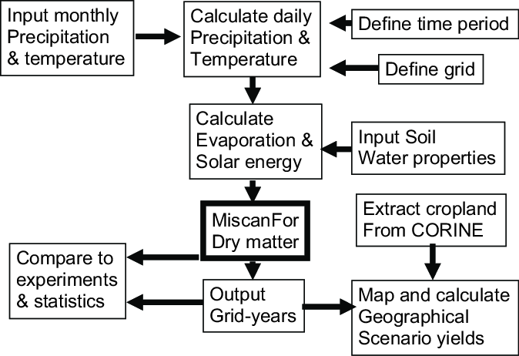

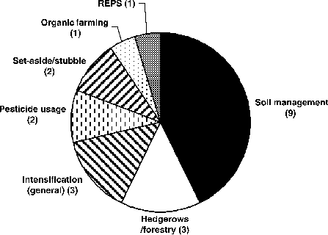 **Fig 1.0**

**Fig 1.1**

**Edyn**

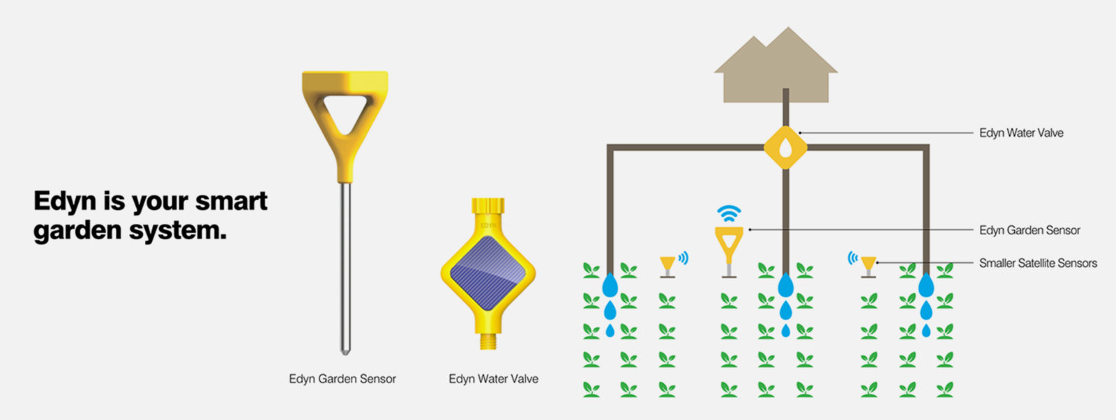 This system uses sensors to measure soil moisture, nutrient levels, and other parameters, and transmits the data to a cloud platform for analysis. The system also includes an automated irrigation system that can be triggered based on the data collected by the sensors. The system can be controlled using a smartphone app, which allows users to monitor their plants and make any necessary adjustments.

**Fig 1.2**

**Parrot Pot**

This system includes sensors that measure soil moisture, temperature, and light intensity, as well as an automated irrigation system that can be triggered based on the data collected by the sensors. The system can be controlled using a smartphone app, which allows users to monitor their plants and make any necessary adjustments.

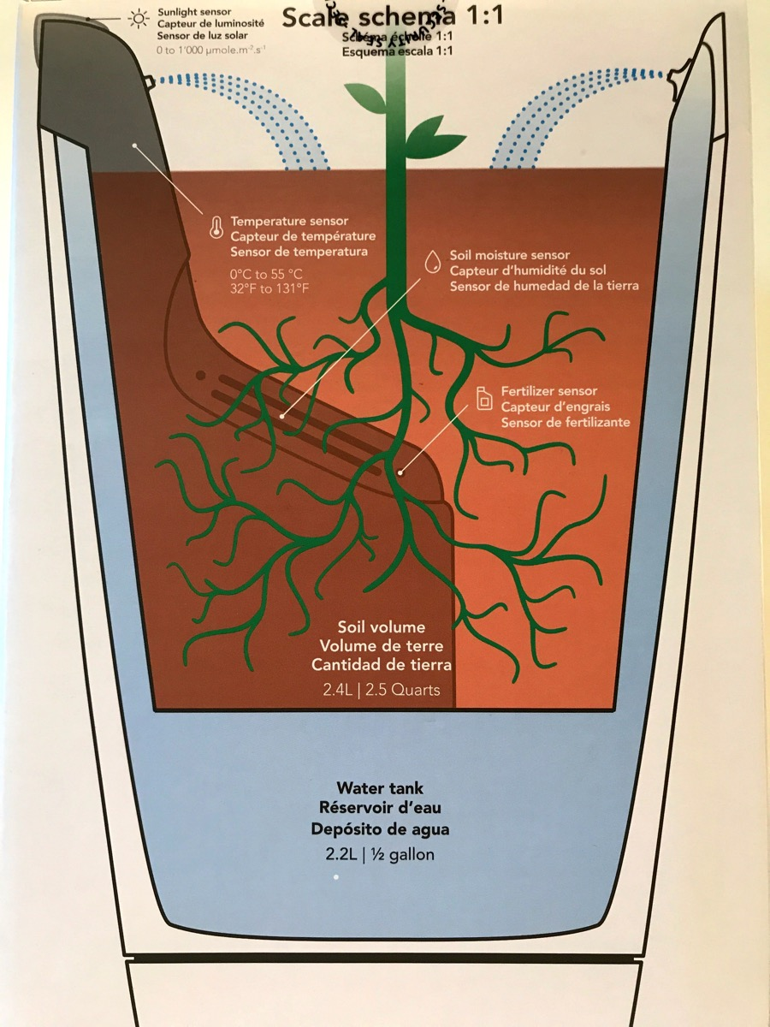

**CHAPTER 4**

**Fig 1.3**

**CHAPTER 4**

**PROPOSED SYSTEM**

Sensors: The soil moisture sensor would measure the moisture content of the soil, while the humidity and temperature sensors would measure the air humidity and temperature, respectively. All of these sensors would transmit the data they collect to the ESP8266 module via a wireless connection.

Wi-Fi module (ESP8266): The ESP8266 module would act as a gateway, receiving data from the sensors and transmitting it to the cloud platform via a Wi-Fi connection. The module would also be responsible for managing communications between the sensors and the cloud platform.

User interface: The system would include a user interface, such as a smartphone app or web portal, that would allow users to access the data collected by the sensors and control the various components of the system. The interface would also provide alerts and notifications if there are any issues with the plants or the system itself.

**PROBLEM STATEMENT**

How can we use sensors and a smartphone app to optimize the care of plants and improve their health and growth?

How can we use the data collected by soil moisture, humidity, and temperature sensors, along with a WiFi connection, to make informed decisions about watering and fertilizing plants?

How can we use a smartphone app to monitor and control the various components of an IoT-based smart plant monitoring system in real-time?

How can we ensure that the data collected by the sensors is accurate and reliable, and how can we prevent errors or malfunctions in the system?

How can we design and implement an IoT-based smart plant monitoring system that is easy to use, cost-effective, and scalable for different plant-growing environments?

**METHODOLOGY**

1. Identify the plants and growing conditions: The first step in implementing the system would be to identify the plants that will be monitored and the growing conditions in which they will be grown. This will help determine the types and locations of sensors and other monitoring devices that will be needed.
2. Select and install sensors and monitoring devices: The next step would be to select and install soil moisture, humidity, and temperature sensors, as well as the ESP8266 module. The sensors would be placed in the appropriate locations around the plant-growing area, while the ESP8266 module would be connected to a power source and configured to transmit data to the cloud platform via a WiFi connection.
3. 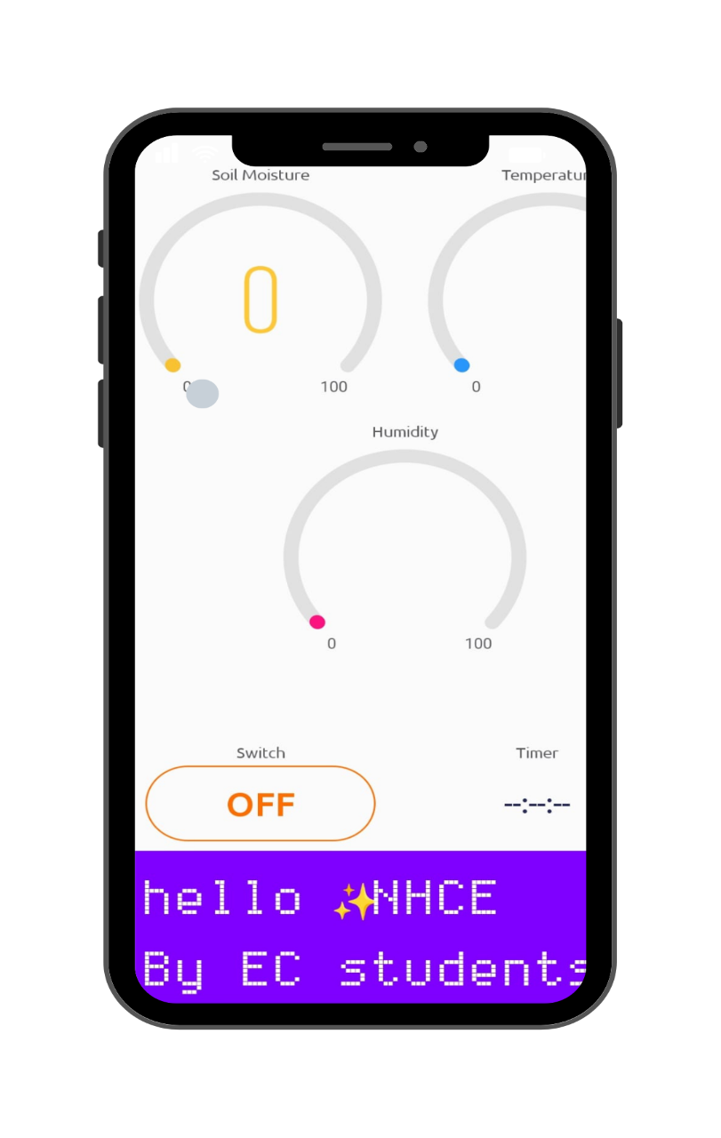Set up the user interface: The system would include a smartphone app or web portal that would allow users to access the data collected by the sensors and control the various components of the system. The app or portal would also provide alerts and notifications if there are any issues with the plants or the system itself

**Fig 1.4**

**CHAPTER 5**

**HAEDWARE AND SOFTWARE SPECIFICATION**

**HARDWARE SPECIFICATION:**

**NODEMCUESP8266 WI-FI MODULE**

The NODEMCU ESP8266 is a Wi-Fi enabled microcontroller development board that is based on the ESP8266 chip. It includes a microcontroller unit (MCU) and a Wi-Fi module, and is designed to be easily programmed and integrated into a wide range of applications.

Some key features of the NODEMCU ESP8266 include:

* Wi-Fi connectivity: The ESP8266 Wi-Fi module allows the NODEMCU to connect to a wireless network and communicate with other devices over the Internet.
* Microcontroller unit (MCU): The NODEMCU includes a microcontroller unit (MCU) that can be programmed using the Arduino programming language.
* I/O pins: The NODEMCU has a number of input/output (I/O) pins that can be used to interface with sensors, actuators, and other devices.
* Onboard USB-to-serial converter: The NODEMCU has an onboard USB-to-serial converter that allows it to be easily programmed and debugged using a computer.
* Compact size: The NODEMCU is small and lightweight, making it easy to incorporate into a variety of projects.

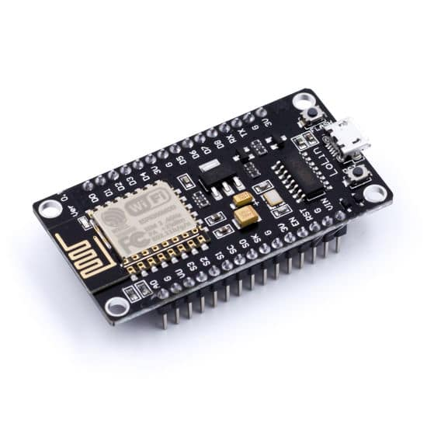

**Fig 1.5**

**SOIL MOISTURE SENSOR**

A soil moisture sensor is a device that is used to measure the amount of water present in the soil. It typically consists of two metal electrodes that are placed in the soil, with an electronic circuit that measures the resistance between the electrodes. The resistance between the electrodes varies depending on the amount of water present in the soil, and this variation can be used to calculate soil moisture content.

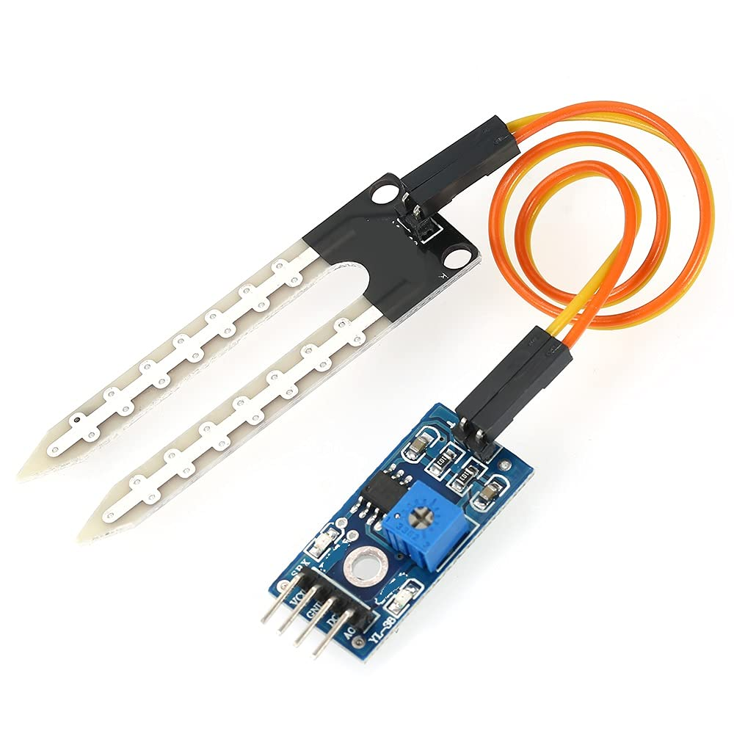There are several types of soil moisture sensors available, including capacitive, resistive, and time domain reflectometry (TDR) sensors. Capacitive sensors work by measuring the dielectric constant of the soil, which varies depending on the water content. Resistive sensors measure the resistance between two metal electrodes, which also varies with the water content of the soil. TDR sensors use radio waves to determine the distance between the sensor and a reflector, which is affected by the water content of the soil.

**Fig 1.6**

**DHT11 TEMPERATURE & HUMIDITY SENSOR**

The DHT11 is a digital temperature and humidity sensor that uses a capacitive humidity sensor and a thermistor to measure the surrounding air. It is a relatively low-cost and low-precision sensor that is widely used in hobbyist and educational projects.

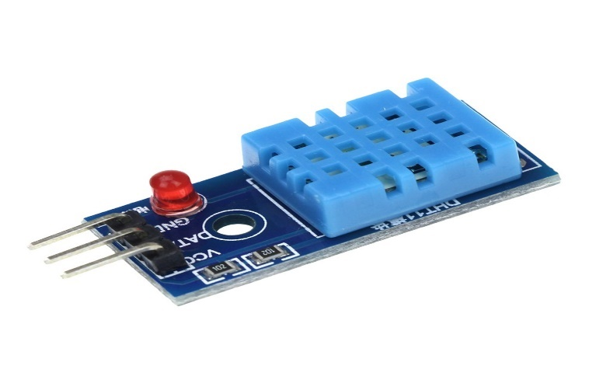The DHT11 has a temperature range of 0-50°C (32-122°F) with an accuracy of ±2°C (±3.6°F) and a humidity range of 20-90% with an accuracy of ±5%. It can communicate with a microcontroller using a single digital pin, and it uses a proprietary protocol to transmit temperature and humidity data.

**Fig 1.7**

**RELYA MODULE**

A relay is an electrically operated switch that is used to control a circuit using a low-power electrical signal. Relay modules are electronic circuits that are used to control and interface with relays. They typically consist of a microcontroller or other control circuitry, as well as connectors for connecting the relay to the circuit being controlled.

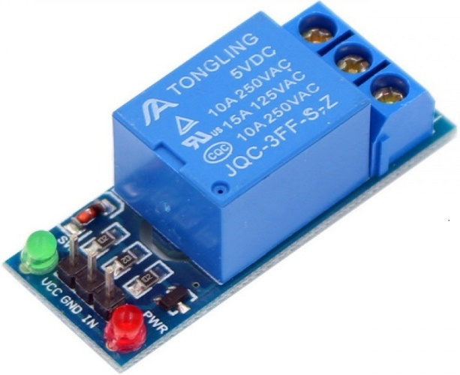Relays are often used to control high-power circuits using a low-power control signal. For example, a relay module could be used to control a 240V AC circuit using a 5V DC control signal from a microcontroller. This allows the microcontroller to safely control a circuit that would otherwise be too hazardous or difficult to control directly.

**Fig 1.8**

**SOLENOID WATER VALVE**

A solenoid valve is an electromechanical valve that is used to control the flow of liquids or gases. It consists of a solenoid, which is an electromagnet that is used to control a valve stem, and a valve body, which contains the flow passage and the valve mechanism.

When the solenoid is energized, the electromagnetic field moves the valve stem, which opens or closes the flow passage. When the solenoid is de-energized, the valve stem returns to its original position, either fully open or fully closed, depending on the design of the valve.

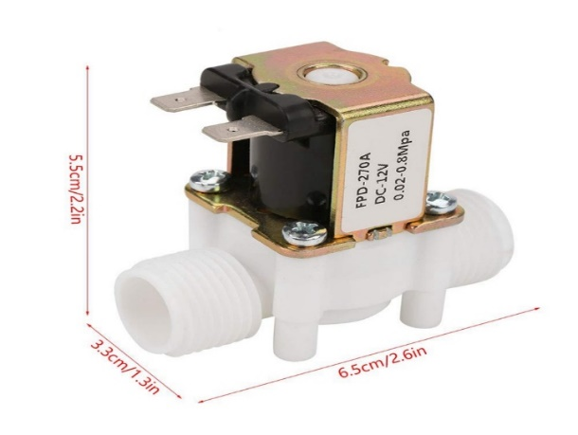Solenoid valves are widely used in a variety of applications, including fluid control, air conditioning, and automotive systems. They are often used in automated systems because they can be easily controlled using an electrical signal.

**Fig1.9**

**CHAPTER 6**

**WORKING**

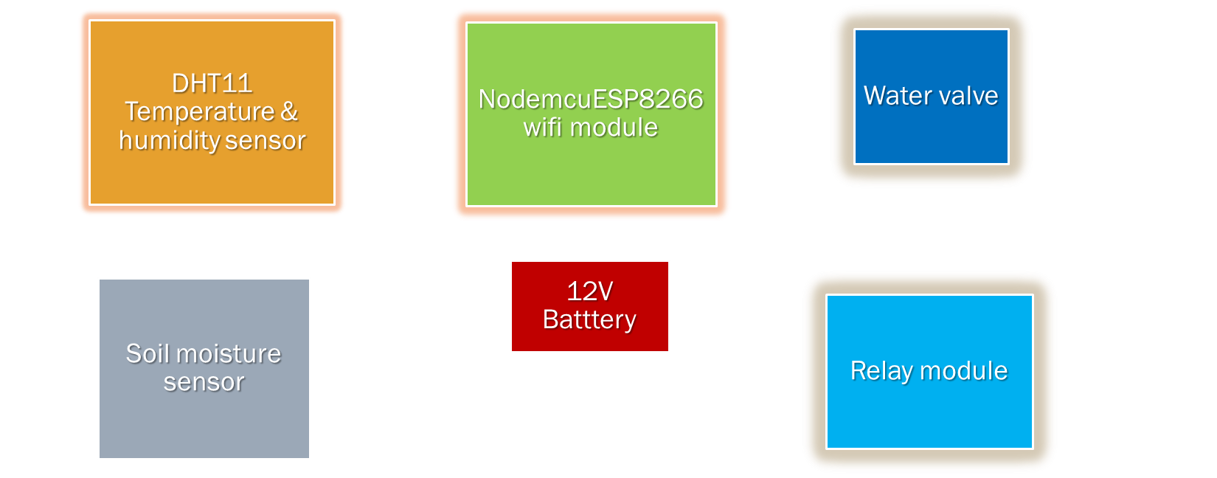**BLOCK DIAGRAM**

An IoT-based smart plant monitoring system can use soil moisture, temperature, and humidity sensors to gather data about the condition of a plant and its environment. The sensors can be connected to a microcontroller or single-board computer, such as a Wi-Fi module which can process the sensor data and send it to a server or app platform.

**Fig 2.0**

The Wi-Fi ESP8266 module can be used to connect the microcontroller to a wireless network, allowing the system to send and receive data over the Internet. This data can be used to control the watering of the plant, for example, by opening or closing a solenoid valve to allow water to flow to the plant.

A user interface, such as a mobile app, can be used to display sensor data and allow the user to control the system remotely. The app can also send notifications to the user, alerting them when the plant needs watering or if there is a problem with the system.

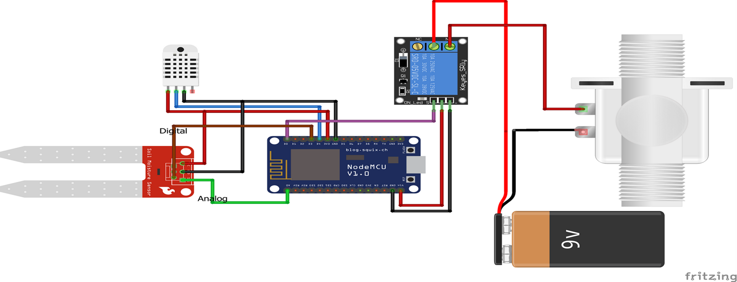**CIRCUIT DIAGRAM**

**Fig 2.1**

**CHAPTER 7**

**ADVANTAGES AND APPLICATIONS**

**ADVANTAGES**

* Improved plant health: By gathering data about the plant's environment, such as soil moisture, temperature, and humidity, the system can provide real-time information about the plant's needs. This can help to optimize the care of the plant and improve its health.
* Remote monitoring and control: The system allows the user to monitor and control the plant remotely, using a smartphone or other device. This makes it easier to care for the plant, even when the user is not physically present.
* Automation: The system can be programmed to automatically water the plant or adjust other environmental conditions based on sensor data. This can help to save time and effort, and can also improve the consistency of the plant's care.
* Cost savings: By optimizing the care of the plant, the system can help to save water and other resources, potentially reducing the cost of plant care.

Overall, an IoT-based smart plant monitoring system can provide many benefits, including improved plant health, remote monitoring and control, automation, data tracking, and cost savings.

**APPLICATIONS**

* Home gardening: The system can be used to monitor and care for plants in a home garden, helping to optimize the growth and health of the plants.
* Agricultural production: The system can be used to monitor and control the conditions in a greenhouse or other agricultural setting, helping to improve crop yield and quality.
* Landscaping: The system can be used to monitor and care for plants in a landscaping setting, helping to optimize the growth and health of the plants.
* Research: The system can be used in research settings to study the effects of different environmental conditions on plant growth and development.

**LIMITATIONS**

* Dependence on technology: The system relies on technology, such as sensors, microcontrollers, and wireless connectivity, which may fail or become obsolete over time.
* Limited control: The system can only control the environmental conditions that it is designed to measure. It may not be able to address other factors that affect plant health, such as pests or diseases.
* Data accuracy: The accuracy of sensor data may be affected by factors such as calibration, interference, and sensor wear.
* Security: The system may be vulnerable to cyberattacks, which could compromise the security of the data and the system itself.

Overall, while an IoT-based smart plant monitoring system can provide many benefits, it is important to consider these limitations and take steps to address them in order to get the most out of the system.

**CHAPTER 8**

**RESULTS AND DISCUSSIONS**

Begin with uploading the code to Wi-Fi module after interfacing all the components and completing all the connection. It is observed that the data we are geeting by the app clearly showing with respect to the realtime & sensors that we are using like temperature sensor,humidity sensor, soil moisture sensor.

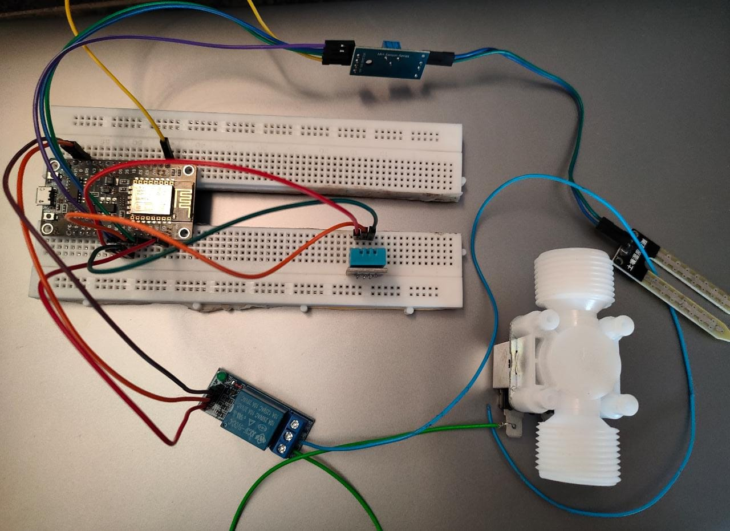

**CHAPTER 9**

**FUTURE SCOPE AND CONCLUSION**

**FUTURE SCOPE**

* Improved sensor technology: Sensors are an essential component of smart plant monitoring systems, and there is potential for significant improvements in sensor technology in the future. This could include the development of more accurate, reliable, and cost-effective sensors, as well as the integration of multiple sensors into a single device.
* Artificial intelligence and machine learning: AI and machine learning algorithms can be used to analyze sensor data and make recommendations for plant care, helping to optimize the growth and health of the plant.
* Integration with other systems: Smart plant monitoring systems could be integrated with other systems, such as irrigation systems or home automation systems, to provide a more comprehensive solution for plant care.
* Increased automation: The use of robotics and other automation technologies could further reduce the need for manual intervention, allowing the system to operate more independently and efficiently.
* Greater accessibility: The development of mobile apps and other user interfaces could make the system more accessible to a wider range of users, including those with limited technical expertise.

**CONCLUSION**

* An IoT-based smart plant monitoring system is a technology that can be used to optimize the care and management of plants. It consists of sensors, a microcontroller or single-board computer, and a wireless connection, and can be controlled using a user interface such as a mobile app. The system can gather data about the plant's environment, including soil moisture, temperature, and humidity, and can be programmed to control the plant's watering and other environmental conditions. There are many advantages to using a smart plant monitoring system, including improved plant health, remote monitoring and control, automation, data tracking, and cost savings. However, there are also some limitations to consider, such as cost, dependence on technology, limited control, data accuracy, and security. The future of smart plant monitoring systems looks bright, with many potential areas for growth and development, including improved sensor technology, AI and machine learning, integration with other systems, increased automation, and greater accessibility.

APPENDEX

SOFTWARE SPECIFICATION

ARDUINO CODE:

//By New Horizon Collage of Engineering E&C Students

// IOT Smart Plant Monitoring System

#define BLYNK_PRINT Serial

#include <SPI.h>

#include <ESP8266WiFi.h>

#include <BlynkSimpleEsp8266.h>

#include <SimpleTimer.h>

#include <DHT.h>

#define BLYNK_PRINT Serial

#include <OneWire.h>

#include <DallasTemperature.h>

#define ONE_WIRE_BUS D2

OneWire oneWire(ONE_WIRE_BUS);

DallasTemperature sensors(&oneWire);

char auth[] ="7pKePBZjoWYelIw6qFqhTS7_J41pfULG"; //Authentication code sent by Blynk

char ssid[] = "ESP8266"; //WiFi SSID

char pass[] = "password"; //WiFi Password

#define sensorPin D3

int sensorState = 0;

int lastState = 0;

#define DHTPIN 2

#define DHTTYPE DHT11

DHT dht(DHTPIN, DHTTYPE);

SimpleTimer timer;

void sendSensor()

{

float h = dht.readHumidity();

float t = dht.readTemperature();

if (isnan(h) || isnan(t)) {

Serial.println("Failed to read from DHT sensor!");

return;

}

Blynk.virtualWrite(V5, h); //V5 is for Humidity

Blynk.virtualWrite(V6, t); //V6 is for Temperature

}

void setup()

{

Serial.begin(9600);

Blynk.begin(auth, ssid, pass);

pinMode(sensorPin, INPUT);

dht.begin();

timer.setInterval(1000L, sendSensor);

Serial.begin(115200);

Blynk.begin(auth, ssid, pass);

sensors.begin();

}

int sensor=0;

void sendTemps()

{

sensor=analogRead(A0);

sensors.requestTemperatures();

float temp = sensors.getTempCByIndex(0);

Serial.println(temp);

Serial.println(sensor);

Blynk.virtualWrite(V1, temp);

Blynk.virtualWrite(V2,sensor);

delay(1000);

}

void loop()

{

Blynk.run();

timer.run();

sendTemps();

sensorState = digitalRead(sensorPin);

Serial.println(sensorState);

if (sensorState == 1 && lastState == 0) {

Serial.println("needs water, send notification");

Blynk.notify("Water your plants");

lastState = 1;

delay(1000);

//send notification

}

else if (sensorState == 1 && lastState == 1) {

//do nothing, has not been watered yet

Serial.println("has not been watered yet");

delay(1000);

}

else {

//st

Serial.println("does not need water");

lastState = 0;

delay(1000);

}

delay(100);}

**REFERENCES**

* "Smart Plant Monitoring System Using the Internet of Things (IoT)" by R. Priya, S. Karthik, S. Naveen Kumar, and V. Subathra, published in the International Journal of Advanced Research in Computer and Communication Engineering, 2017.
* "IoT-Based Smart Plant Monitoring Systems: A Review" by H. M. F. Chowdhury and M. A. K. Azad, published in the IEEE Access journal, 2019.
* "An Internet of Things-Based Smart Plant Monitoring System for Smart Agriculture" by K. S. Wang, S. S. Huang, C. W. Tsai, and Y. C. Chen, published in the Sensors journal, 2017.
* "A Review of Smart Agriculture Systems Based on the Internet of Things" by Y. Liu, Z. Song, Y. Duan, and J. Han, published in the IEEE Access journal, 2018.
* Prof. Kawale Jayashri , Sanjay More, Akshay Bankar, Ganesh Dongre, Pooja Patil, “I0T BASED
* SMART PLANT MONITORING SYSTEM”, International Journal of Advance Research in Science and Engineering, Vol. No. 7.
* Prof. Prachi Kamble, “IOT Based Plant Monitoring System”, ITIIRD, Vol. No. 2. [3] Yogendra Parihar, “Internet of Things and Node MCU”, JETIR, Vol. No. 6.
* Gabriel, “Monitoring Moisture and Humidity using Arduino Nano”.